|  |  |
| --- | --- |
| **Front End Development**  Diploma in IT, ISF  2018/19 Semester 2 | Week **2** |
| 4 Hours |
| **Creating Tables** | |

**Activities**

**Task 1**

* Read Part II – HTML For Structure (Chapters 4, 5, 6, 8) from the textbook.
* Download the following file from MEL :-
  + jenskitchen.zip
* Complete Part 1 of the Week 2 Practical

**Task 2**

* Download the following file from MEL :-
  + Main.html
* Complete Part 2 of the Week 2 Practical.

**Task 3**

* Download the following files from MEL :-
  + styles.css
* Ensure file is in css folder
* Complete Part 3 of the Week 2 Practical.
* Submit the completed practical files (Part 1, 2 & 3) to your folder in //ictspace/FED by Sunday 2359hrs of Week 2.

If you have any questions please contact your tutor via Microsoft Teams.

**Part 1: Linking web pages**

1. Unzip jenskitchen.zip to your week02 folder in your hard disk
2. Attempt Exercise 6-7 page 123 of the textbook.
3. Test index.html in a browser to ensure it is able to link to the various web pages correctly.

**Note:** Since CSS is used to style web pages, there are CSS in the html pages for this practical. Please be informed that you will learn CSS in detail later.

**Part 2: Table with column groups with styling**

1. Open the Main.html for editing in Visual Studio.
   * Right click on Main.html and select open with Microsoft Visual Studio 2017
2. Add relevant code into Main.html to create the following table as shown below.
3. Ensure the meta tags for author and description are updated accordingly.

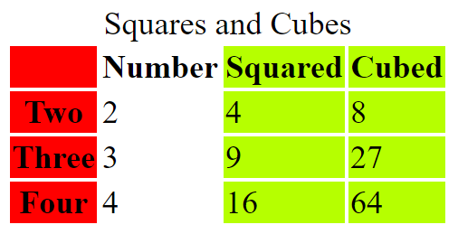

1. Save the file as **SquaresAndCubes.html** and view in browser.
2. Experiment with different colours for the column groups.

**Challenge!**

Modify the code to display the table as follows.

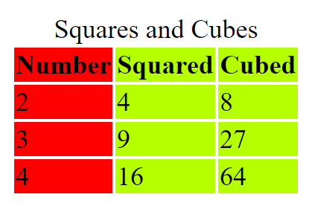

**Part 3: Creating your timetable**

1. Launch Visual Studio.
2. Create a new project and name it as **Week2Practical**.
   * If necessary, refer to Week 1 Practical how to create a new project
3. Add a new HTML page and name it as **MyTimetable.html**.
4. Enter the meta tags for author and description.
   * If necessary, refer to Week 1 Main.html source
5. Type the title as “My Timetable”.
6. Within the <body> tags start with a <table> tag.
7. Type caption as “My Timetable”.
8. In the first row use <th> to create the column headings.
9. In the subsequent rows, use <th> for the time and <td> for other columns.
10. Use rowspan attribute of <td> to specify the number of rows for each lesson.
11. Continue to add rows to complete the table.
12. Save the file and view in browser to see how it looks.

Without styling your timetable would look as below:

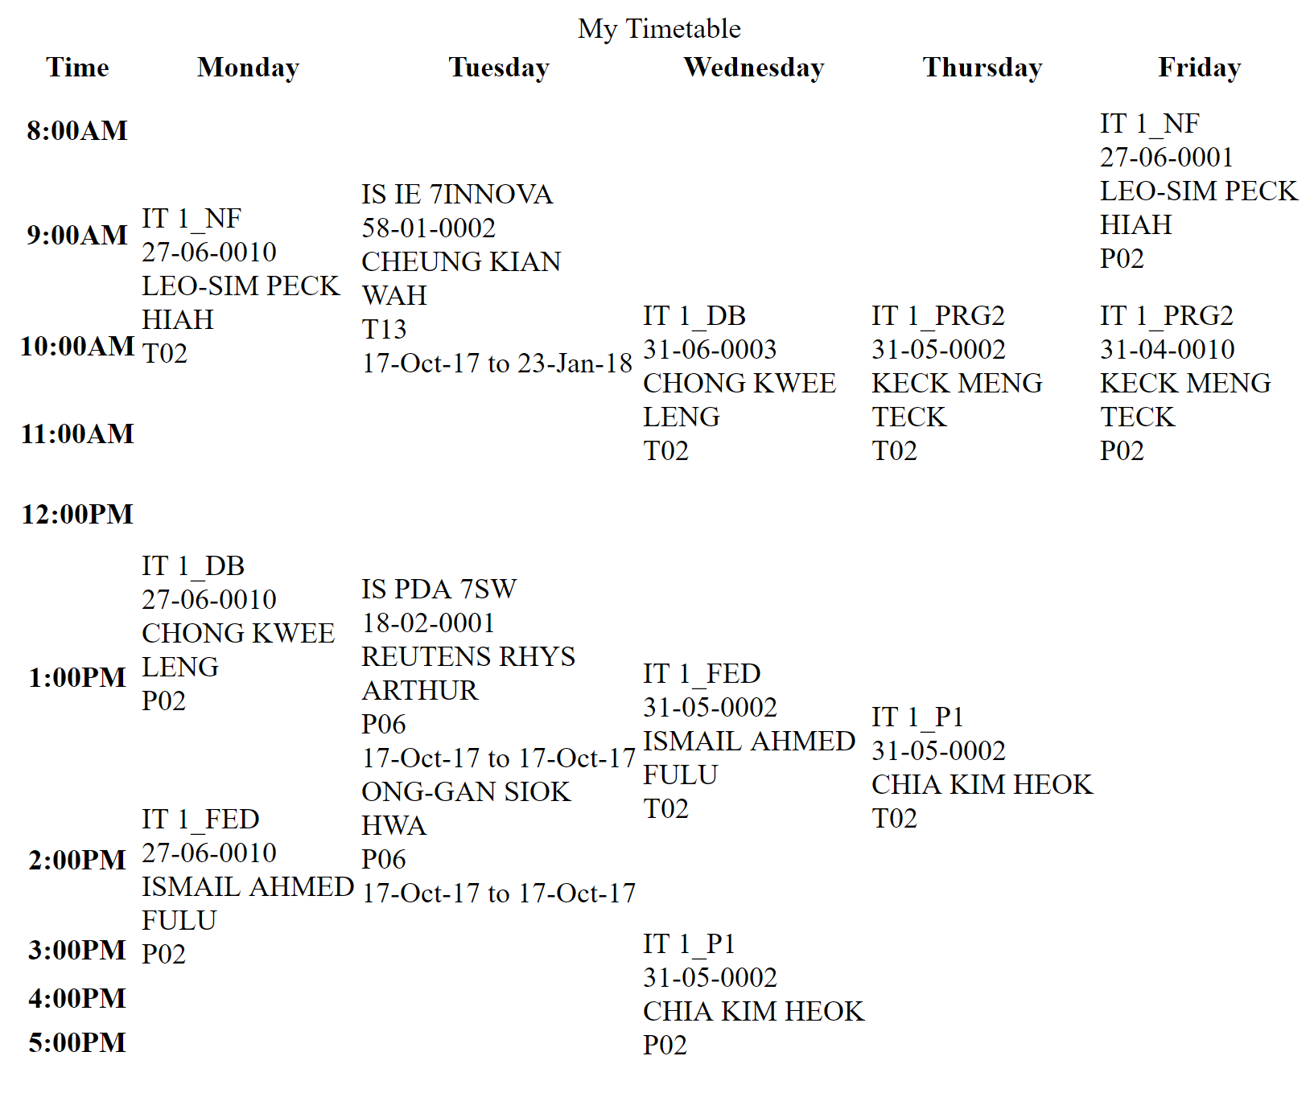

|  |
| --- |
| Note: Feel free to use your own time table if you want to. |

**Challenge**

Use styling to make the timetable look as below:

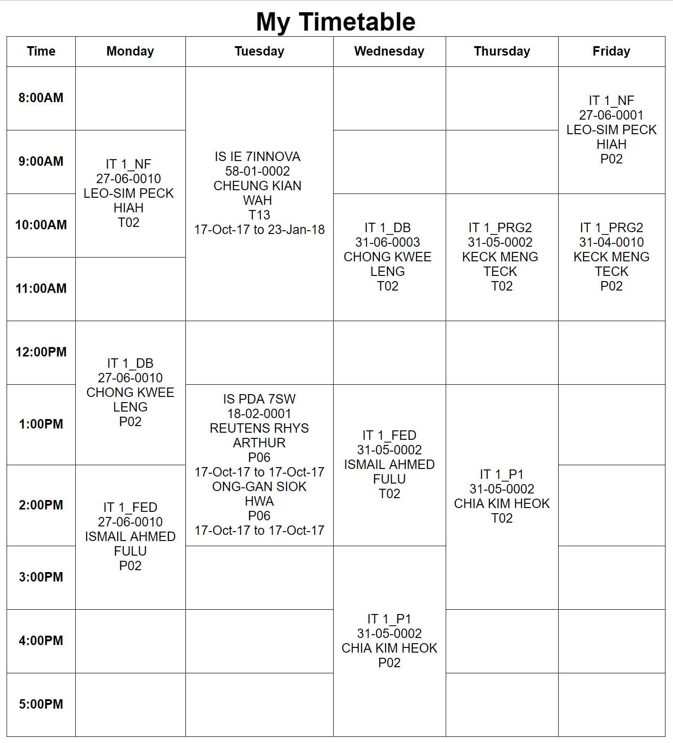

**Note:** Since CSS is used to style web pages, there are CSS in table creation for this practical. Please be informed that you will learn CSS in detail later. For now, suffice to just follow instruction.

Include in your HTML <head> tag, the following HTML code (highlighted in yellow).

<head>

<link rel="stylesheet" href="css/styles.css">

</head>

Just for information only

|  |
| --- |
| Basically, the *styles.css* file includes some of the styling used for styling the timetable:   * For the entire table: font-family: Arial, Helvetica, sans-serif; and text aligned centre * Caption: 2 times the font size and bold * Thin solid border for tr, th and td * Height of the rows: 80px, except the first row |

1. Copy the entire **Week2Practical** folder to your folder in \\ictspace\FED.

== End of Worksheet ==